ECON 357 Assignment 1 (Version B)
This assignment is worth a total of 100 marks. Prepare responses to the following questions in a single document. Make sure to show your calculations.

- (a) For each city across Canada, economists construct a price index for a similar basket of goods. In Calgary (AB) the index in 2017 is 122.00, and in Vancouver (BC) the index in 2017 is 112.40. If you have been offered $125,000 for a job in Calgary and $110,000 for a similar job in Vancouver, which job affords you the highest purchasing power of the bundle of goods in the price index? Use the Calgary value as the base. 6 marks

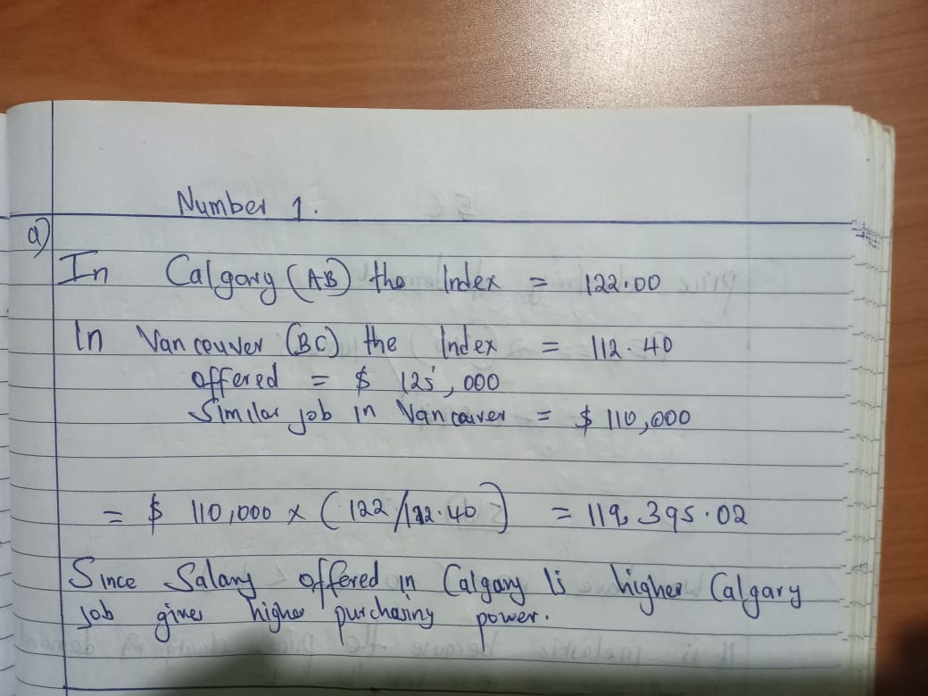
(b) For each of the following statements, indicate if it is a positive statement or normative statement and why. 4 marks
- When the price of a good goes up, firms produce more of it.
This is positive statement: it is narrating simple facts in the economy.
- The taxes paid by the poor should be reduced in order to improve the income distribution in the Canada.
This is normative statement: it is simply advising that taxes should be reduced to the poor people in Canada.

A carbon tax on fossil fuels is designed to reduce automobile emissions and reduce the external costs of air pollution.
This is positive statement: it is narrating simple facts about reduction of air pollution in atmosphere.

- Economists use minimum wage law to predict how many workers might lose their jobs when minimum wage increases.
Normative statement: It is opinion based not based on observations and pridictions.

- (a) Linda’s utility for Fish (F) and soft drink(S) can be represented as U = ½ F* ½ S. Draw the indifference curve that yields a utility level of 9. Calculate the MUF, MUS, and MRS of F for S on that indifference curve when S = 3. 4 marks

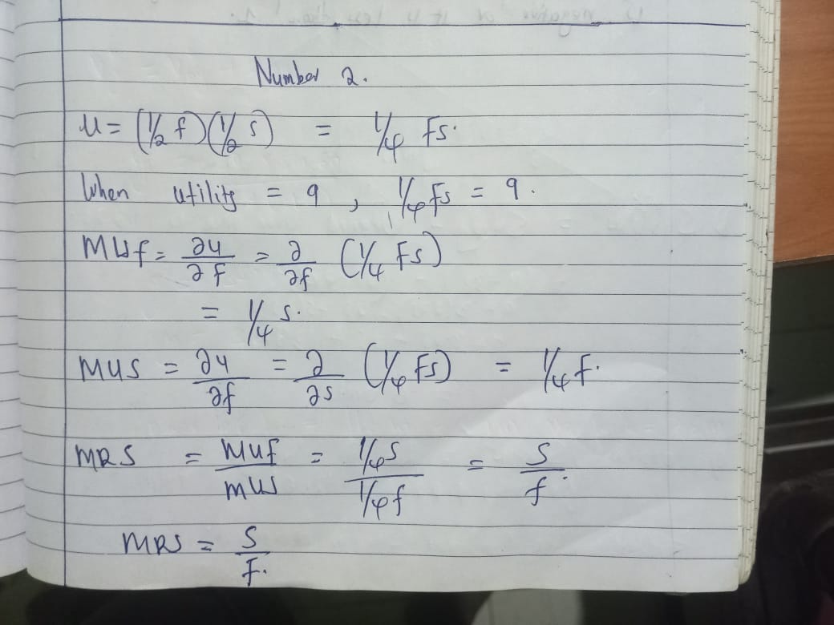

(b) Consider Linda's utility function: U(X,Y) = 6 XY, where X and Y are two goods. Answer parts i and ii based on the assumption that Linda consumed 15 units of X and received 360 units of utility. 8 marks
- How many units of Y must she consume?
- Would a market basket of X = 12 and Y = 5 be preferred to the above combination? Explain your answer.

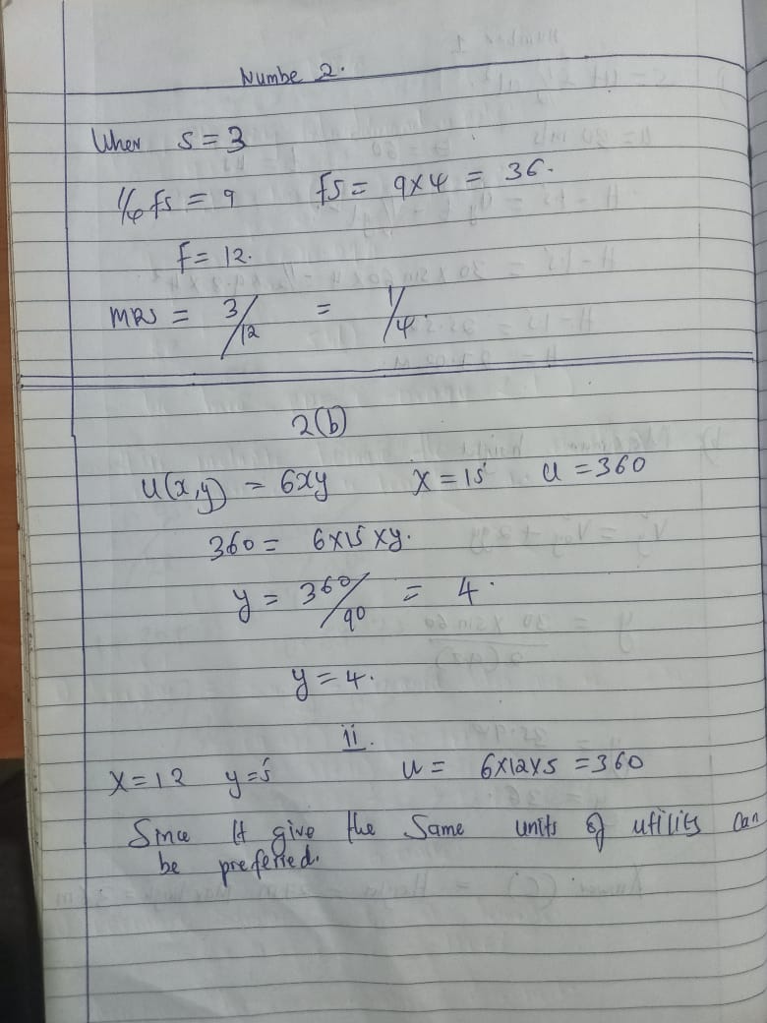

- Suppose the quantity of good X demanded by consumer 1 is given by:
Q_{DX1} =62 – 3P_{X} + 0.35I + 0.3P_{Y}
And the quantity of good X demanded by consumer 2 is given by:
Q_{DX2} = 10 – 2.5P_{X} + 0.2I + 0.6P_{Y}
Answer the following questions and ensure that you show ALL calculations.

(a) What is the market demand for good X? 4 marks

Market demand = Q_{DX1} + Q_{DX2}
= [62 - 3P_{X} + 0.35I +[ 0.3P_{Y} + 10 - 2.5P_{X} + 0.2I + 0.6P_{Y}
= 72 - 5.5P_{X} + 0.55I + 0.9P_{Y}

(b) Using the first demand function:
(Q_{DX1} =62 – 3P_{X} + 0.35I + 0.3P_{Y}),
and given:
P_{X}=$11, P_{Y}=$22 and I=$120,
determine the following and interpret your results:

- price elasticity of demand (E_{D}) 4 marks
-3 * (11 / 77.6)
= -33 / 77.6
= -0.42
The absolute value of PED is 0.42. Since PED is less than 1, demand is inelastic.

- cross elasticity of demand (E_{XY}) 4 marks

0.3 * (22 / 77.6)
= 6.6 / 77.6
= 0.08
Since, the CPED is positive, the two goods are substitutes

- income elasticity of demand (E_{I}) 4 marks
= 0.35 * (120 / 77.6)
= 42 / 77.6
= 0.54
Since IED is positive and less than 1, the good is a normal good.

- The production function for Company X is 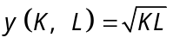. K represents the number of robot hours used in the production process while L represents the number of labour hours. Using the information in the table below, sketch the representative isoquant for company X’s production process, and briefly explain your answer. 5 marks

Output | K | L
12 | 72 | 2
12 | 24 | 6
12 | 8 | 18
12 | 4 | 36
12 | 2 | 72

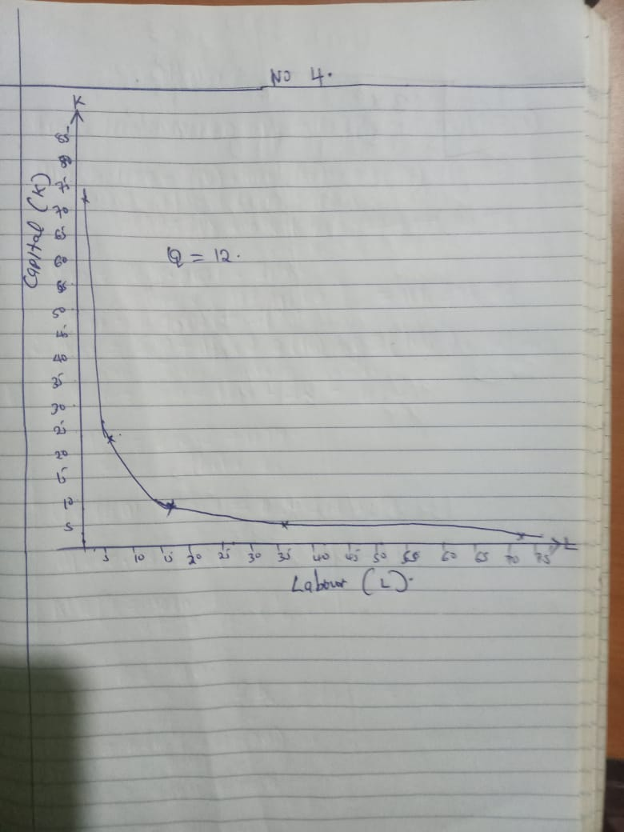

- Given the following demand and supply functions:
Q_{DX} = 1600 - 3P_{X} + 0.4P_{Y} - 0.3P_{Z} + 0.003I
Q_{SX} = 500 + 15P_{X} - 2W - 0.3R
Where: P_{Y} = $160; P_{Z} = $55; I = $4850; W = $11; R=$145

(a) What is the equilibrium price? 4 marks
(b) What is the equilibrium quantity? 4 marks
(c) Calculate the point price elasticity of demand, at the equilibrium values. Use the equilibrium price and equilibrium quantity in part (a). Show your calculations. 3 marks
(d) Find the point income elasticity of demand. Interpret your result. 3 marks

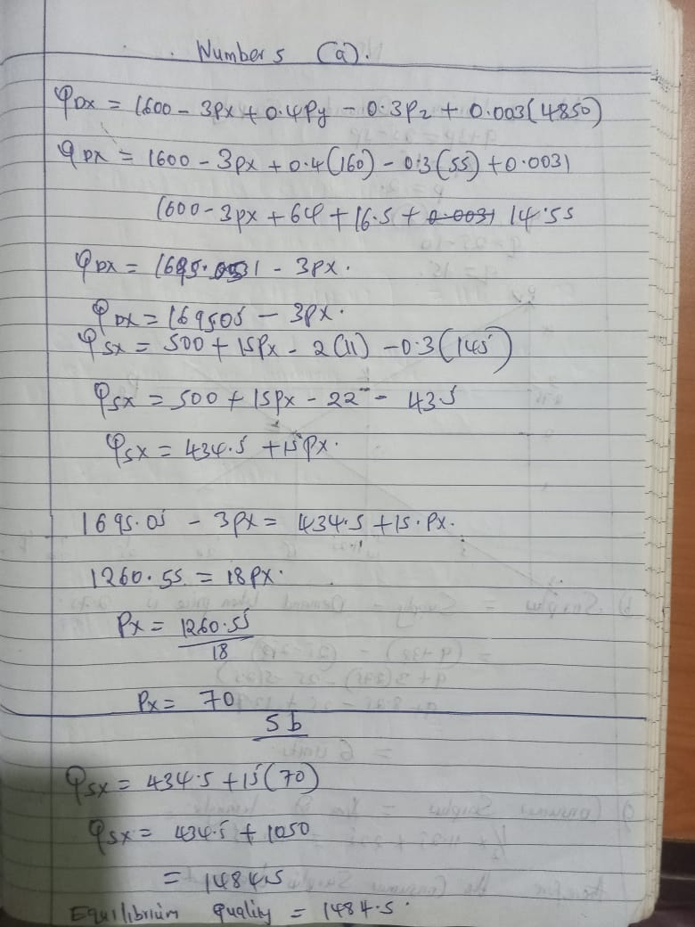\

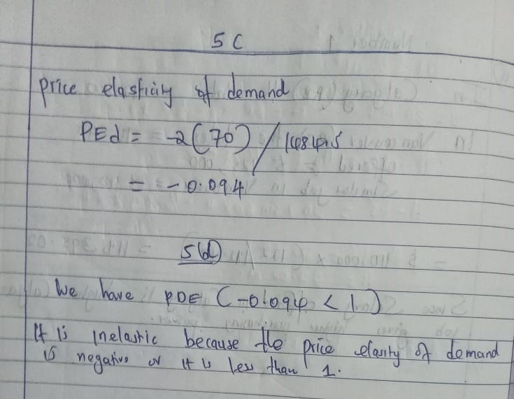
- An Alberta farmer sells corn in a perfectly competitive market. The market supply and demand curves are given by the following equations:
Q_{D} = 25 – 5P
Q_{S} = 9 + 3P
where Q_{D} and Q_{S} are quantity demanded and quantity supplied measured in bushels, and P = price per bushel.

(a) Determine consumer surplus at the equilibrium price and quantity and graphically show CS, make sure to label your graph. 5 marks
(b) Assume that the government has imposed a price floor at $2.75 per bushel and agrees to buy any resulting excess supply. How many bushels of Corn will the government be forced to buy? 5 marks
(c) Based on your answer for part (b), calculate consumer surplus with the price floor. How it is different from your answer for part (a)? 5 marks

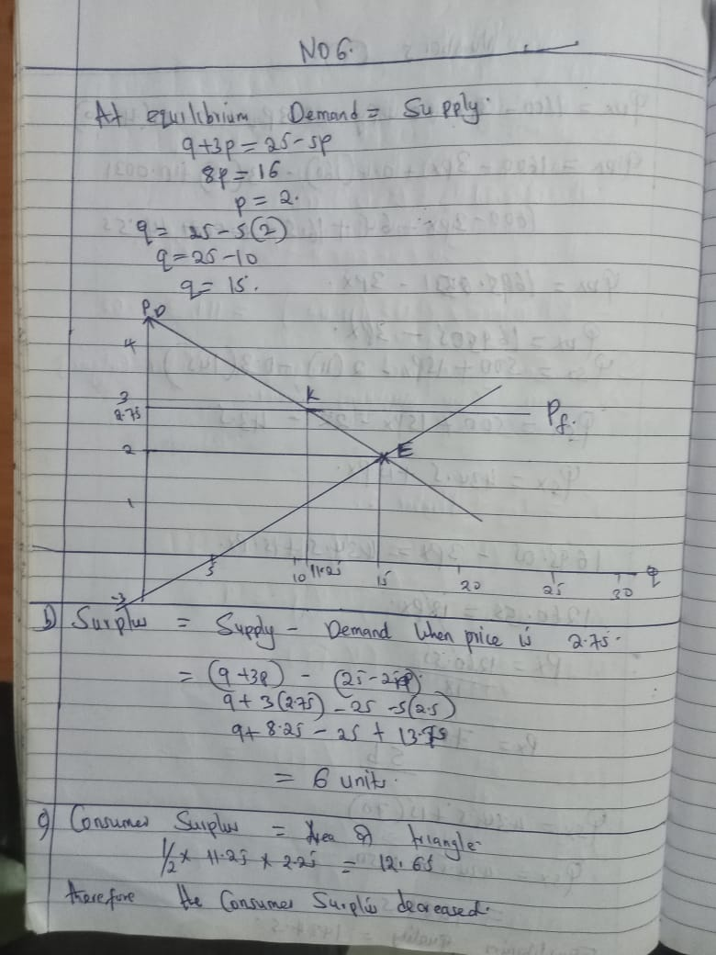

- Given the following production function: q = 10KL.
Assume that w = 25, r = 75 and C = 1200.
(a) Mathematically find the minimum cost combination of capital and labour to produce a given level of output. 4 marks
(b) Does the production function in part (a) show increasing returns to scale, decreasing returns to scale, or constant returns to scale? Explain. 4 marks
(c) Using isoquants and isocosts, graphically illustrate the effect of an increase in the wage rate, assuming the firm is producing at the same level of output. 4 marks

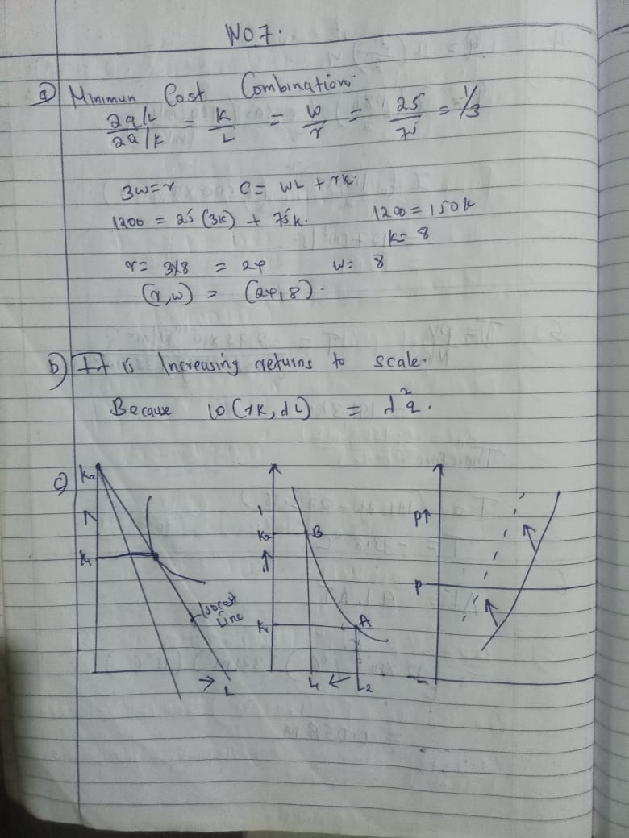

- Given the following combinations for Good X and Good Y:

Combination | Good X | Good Y
A | 1 | 30
B | 6 | 18
C | 12 | 10
D | 20 | 6
E | 32 | 4

(a) Graph the indifference curve by plotting the five combinations of good X and good Y on the same diagram (put good X on the horizontal axis and good Y on the vertical axis). 6 marks
(b) Given I = $182.40, PX = $7.20, and PY = $9.60, graph the budget line on the diagram from part (a). Also, determine the slope of the budget line. 6 marks
(c) What combination of good X and good Y maximizes the consumer’s level of satisfaction? Why? 4 marks

